**TAX STATEMENT PRODUCTION AND DELIVERY**

Contents

**I.** **Scope** 3

**II.** **Detailed Procedure** 3

Step 1: **Locate Tax Statement and Verify Information** 3

**Step 2: Add Tax Information** 6

**Step 3: Add a Requirement, if the taxes are DUE or DELINQUENT** 12

**Step 4: Complete Actions** 13

**Step 5: Pending Tax Data Actions** 16

**STEP 6: DELIVERY** 19

**III.** **Index/Reference** 23

# **Scope**

The scope of this document is to detail out the procedures to verify the Items on the Search Data/Taxes tab of Resware, Complete the required actions, and deliver Tax Statement to the Client. This is known as Tax Statement Production and Delivery.

Types of Tax Statements and Process:

There are a different scenarios when processing the tax statements:

* Processing tax statement when search has not yet been received/NEW ORDER: If the search package has not yet been received OR title documents have not yet been delivered to the Client, The tax statement info will **be entered** and actions completed. No delivery.
* Processing tax statement for Delivery to Client: When title has been approved and delivered: Revised title commitment and tax statement will be delivered.

# **Detailed Procedure**

The Queue for Tax Statements is located in the Refinance- Title Production Queue:

* Client: Select Client assigned to be processed.
* Action: Review Tax Cert

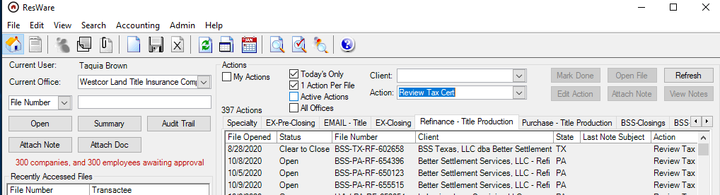

Select File to start process.

### Step 1: **Locate Tax Statement and Verify Information**

The tax statement will be available in the ‘Documents’ tab as document type ‘Tax Statement’. Open the document by double clicking on the document type.

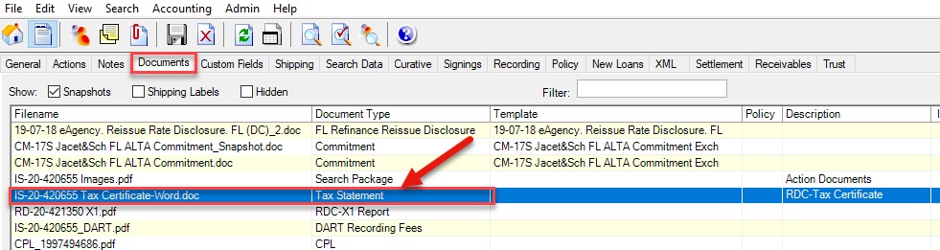

* Once the document is open, verify that the property address, city and county matches with the information reflecting in the Search Data Section of Resware. Review Borrower Name listed to confirm same on file.

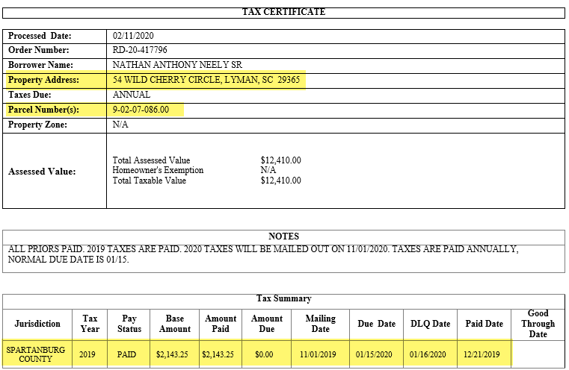

* Also ensure that the parcel ID is reflecting in ‘General->Property’ tab. Else, add the parcel ID by double clicking on partner type “Property” and then entering the parcel ID against the field “Parcel ID #1”. NOTE: We will use the tax ID provided on the tax statement if varies in Search Data.

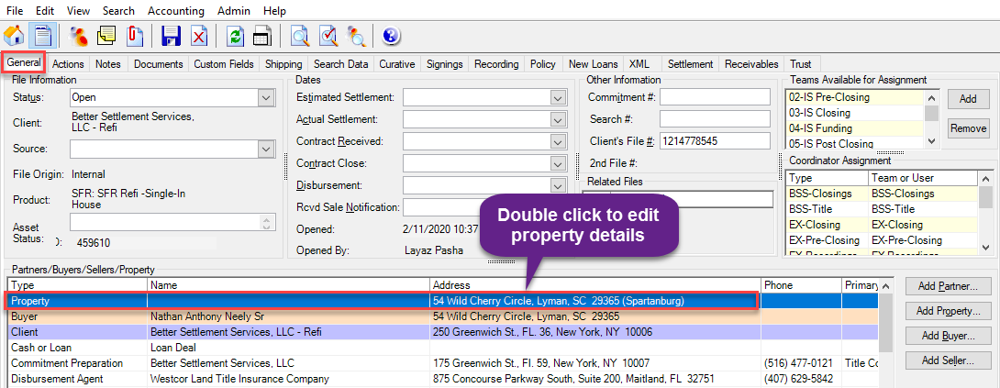

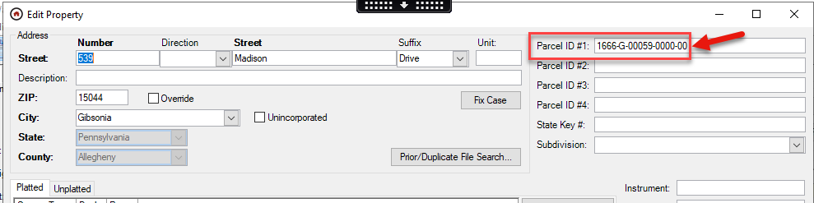

**Note**: If the property has more than one parcel ID, enter these IDs in the fields: Parcel ID #2, Parcel ID #3, etc.

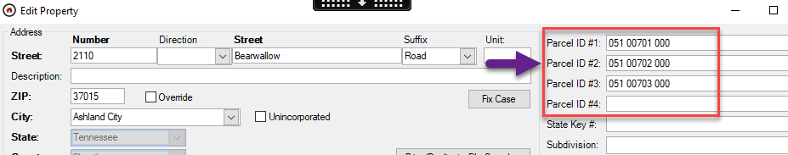

### **Step 2: Add Tax Information**

The user should now go to the ‘Search Data->Chain of Title/Taxes’ tab and enter the tax information under ‘Taxes’ section. If it is already updated, verify that the information entered is accurate.

**Note**: If the property has more than one parcel number, re-follow steps below to add tax info

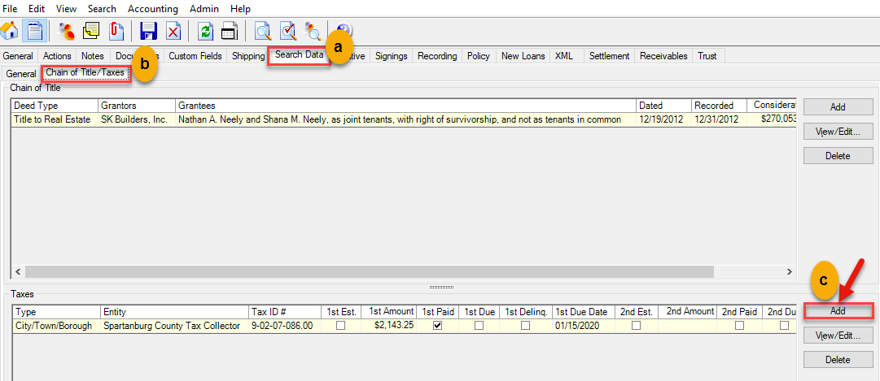

In the tax details page, enter the following information:

1. Enter the tax type and Calendar/Fiscal Tax year
2. The Tax ID number. Multiple parcel numbers will be available in the drop down, once the user has updated these in the “General” tab.
3. The assessed value of the property
4. Taxing entity details

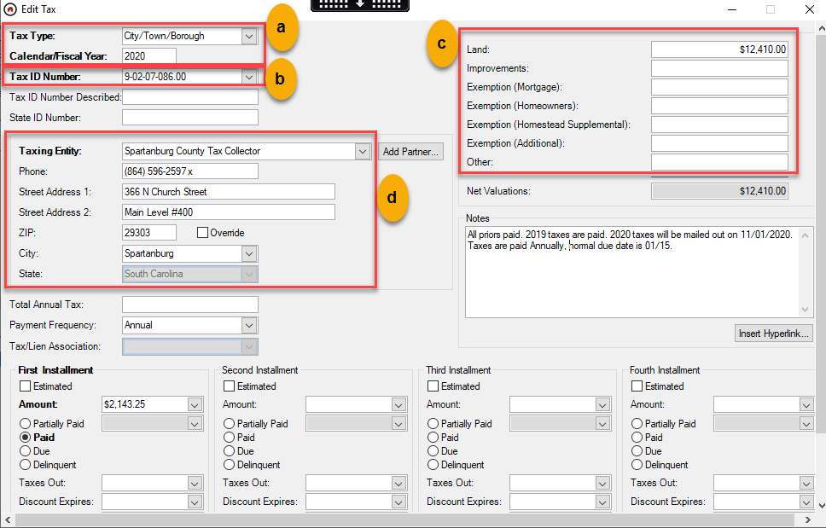

Snapshot of Tax Statement showing the above information.

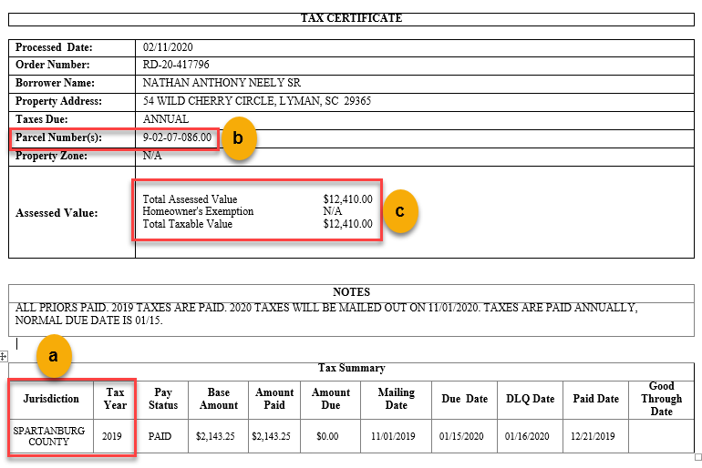

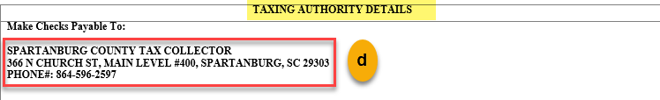

1. Enter the amount of the taxes
   1. If the taxes are paid, enter the paid amount
   2. If the taxes are due, enter the due amount
   3. If the taxes are delinquent, enter the delinquent amount
2. Choose if the taxes are Partially Paid/Paid/Due/Delinquent
3. Enter the dates
   1. If the taxes are paid, enter the paid date
   2. If the taxes are due, enter the due date
   3. If the taxes are delinquent, enter the delinquent date
4. Click on ‘Save’ to save the changes

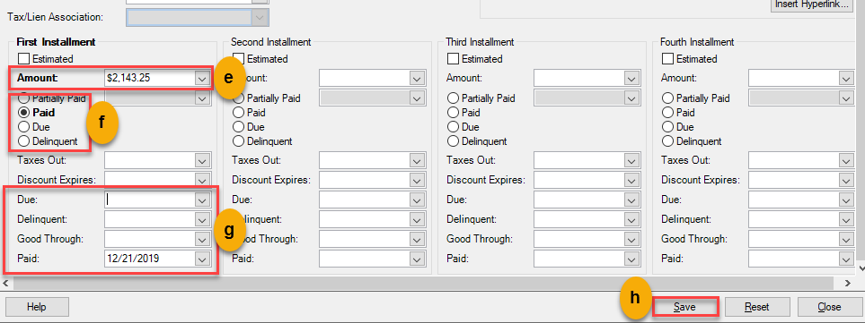

Snapshot from the tax statement showing the above information.

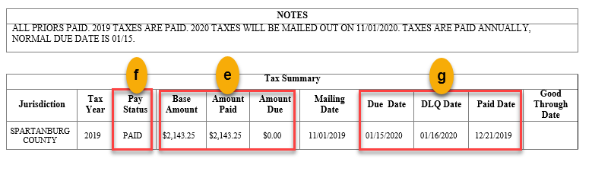

#### PA Tax Statement:

Taxes will need to be entered per tax type (Township/County/School). Please note all tax info listed within will need to be copied in the notes of the 1st tax row listed. Please follow Step 3 Add tax info for each line. When complete, the 1st tax line NOTES should show as follows:

Example 1: You will have 2-3 rows for PA files. NOTE: If tax amount are combined, you may only need to add 2 (ie: Township and County are paid to the same tax collector)

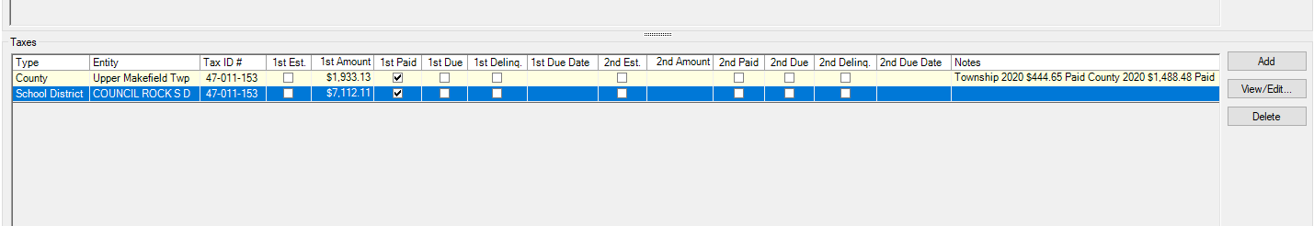

Example 2: Note how the tax info note is listed. This can be done by copying the information from the tax statement

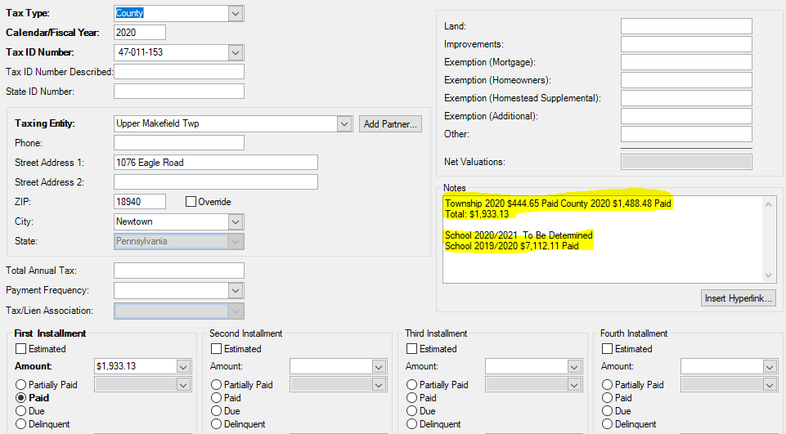

Fig 3: PA Tax Statement

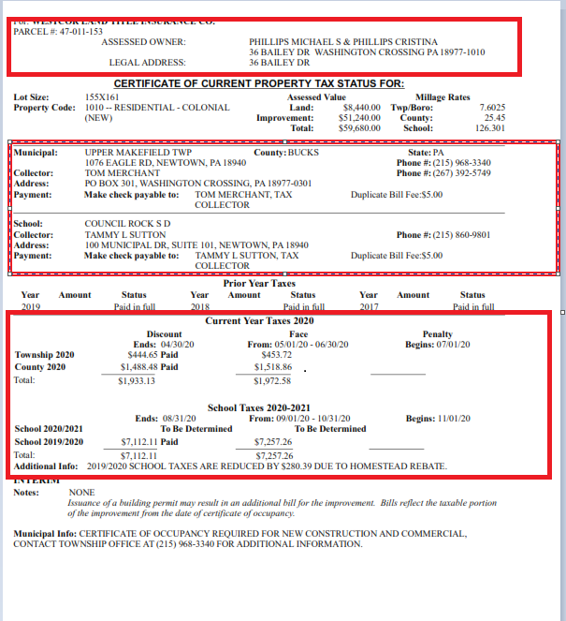

Fig 4: PA Tax Statement:

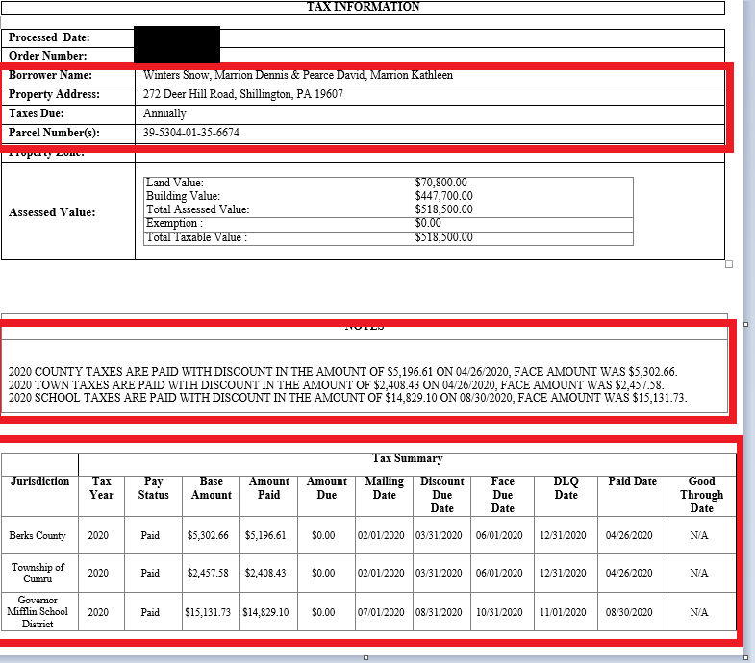

### **Step 3: Add a Requirement, if the taxes are DUE or DELINQUENT**

**PAID TAXES:** No requirement will be added to the Commitment.

The user has to click on the ‘Add’ button, under ‘Search Data->General->Liens & Requirements’ tab to add the requirement, if the taxes are **due within 60 days or are delinquent**.

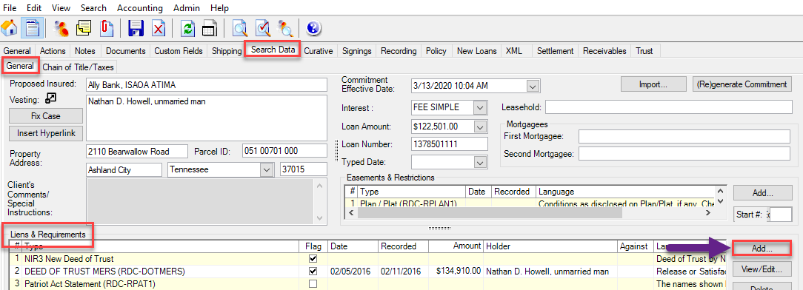

**TAXES DUE:** The requirement type will be ‘payment’ and the language will auto populate.

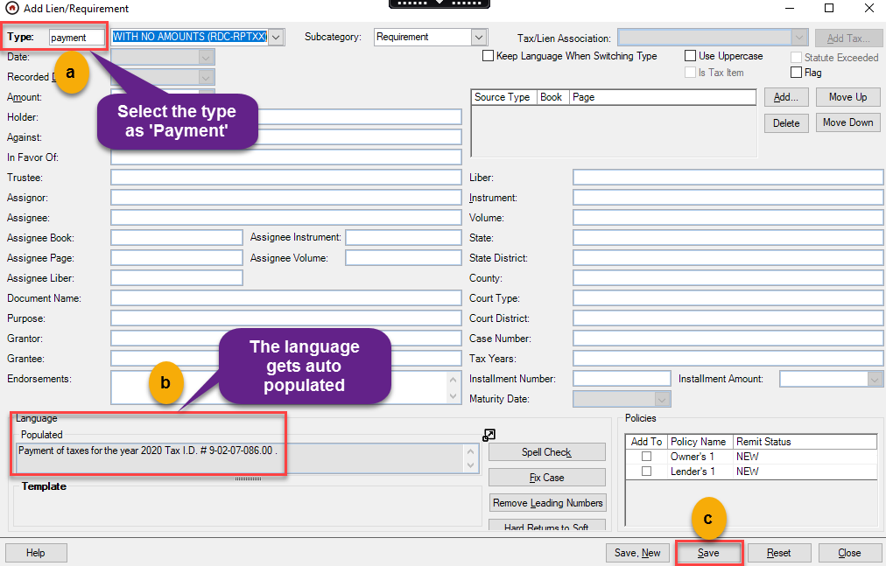

NOTE: If the parcel ID number does not pull into the Populated Language, go to Property Partner and add Parcel Number.

Upon completion of adding Tax info, Regenerate the Commitment. **NOTE: If search is not yet in – DO NOT GENERATE COMMITMENT.**

### **Step 4: Complete Actions**

When Tax Cert has been received and uploaded to the IS side, Action 864: Tax Certificate Ordered & Pending is auto completed. Note: If the search package has not yet been received OR the Title Documents are not yet approved - STOP after Completing Action 871

- Action 850 – Review Tax Cert will start. Complete this action:

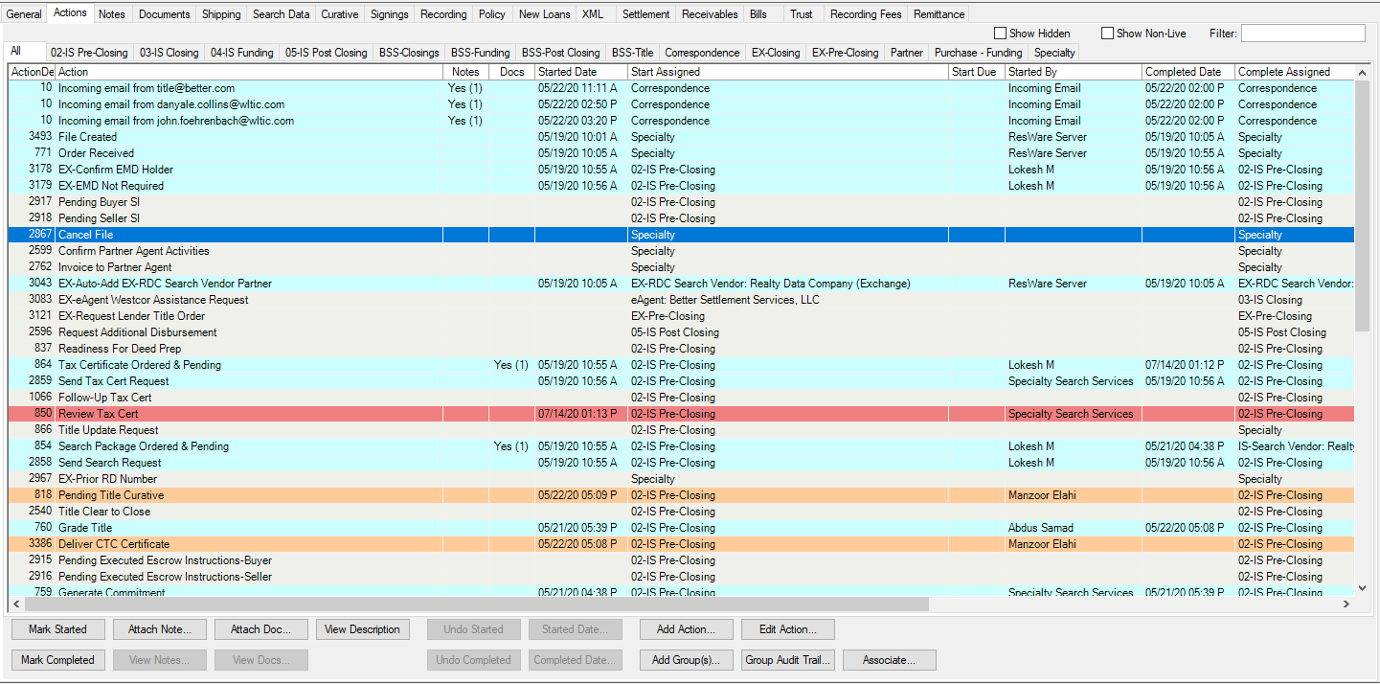

If Tax Statement is correct, select option 1. No Defect

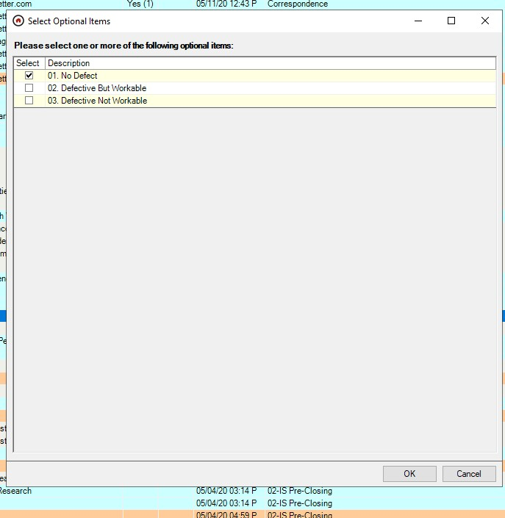

NOTE: Option 2: Defective But workable – select if there is a discrepancy in the address, info is not all available/pending.

***Please note that if the address is incorrect, please manually revise and reload to the file. NOTE: Option 3: Defective Not Workable: This will be used if the tax statement uploaded is for the wrong property or if the wrong info has been listed on the tax statement.

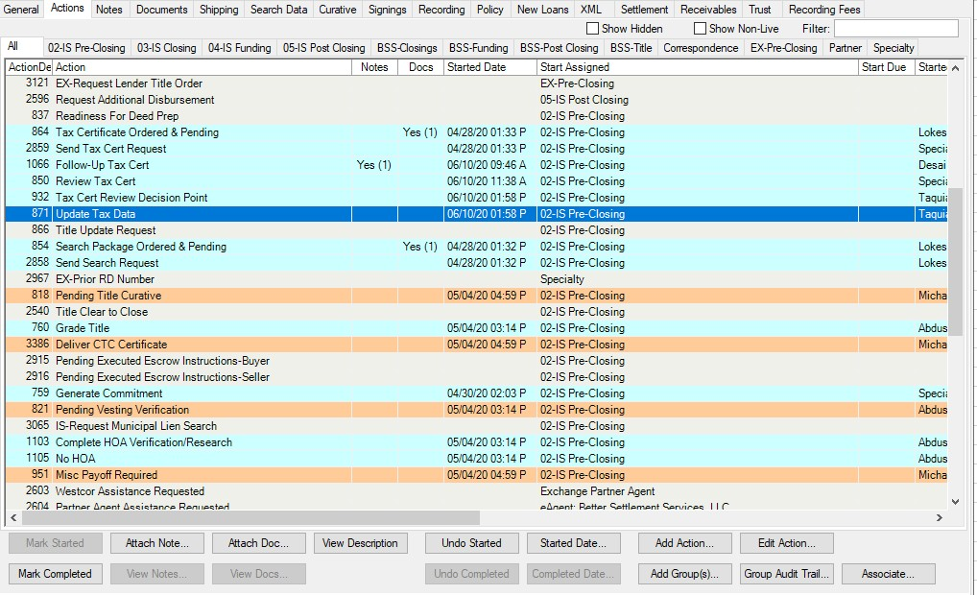

- Complete Action 871: Update Tax Data

Select Option Commitment Previously Generated: No

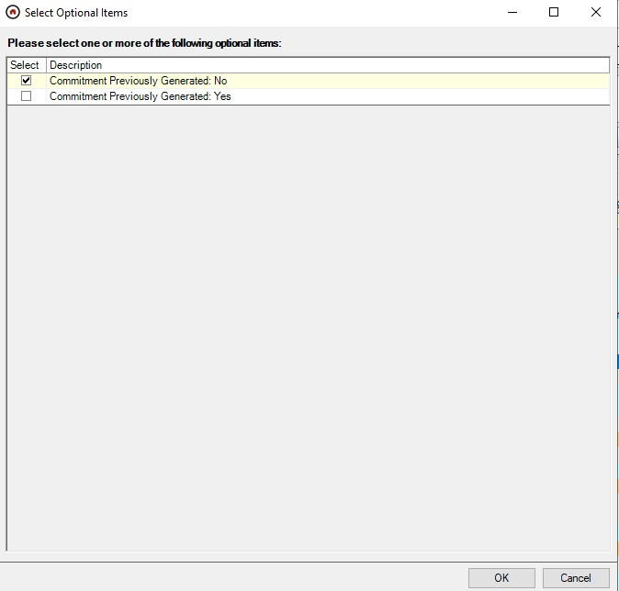

### **Step 5: Pending Tax Data Actions**

When final title documents are sent with the Tax Statement Pending, and the Pending Title Curative actions are completed. One of the options to choose is “Pending Tax Data.” When the tax statement is received, along with the Review Tax Statement actions, Action 817 – Pending Tax Data will need to be completed:

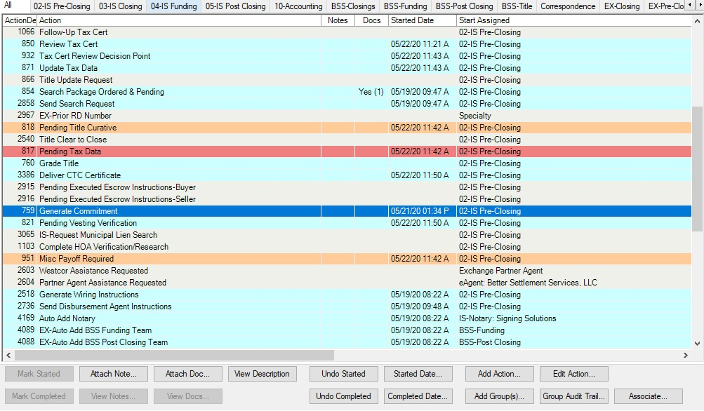

Complete Action 817 – Pending Tax Data. Upon completion, optional items will populate. Select

**Title Clear to Close? – NO**

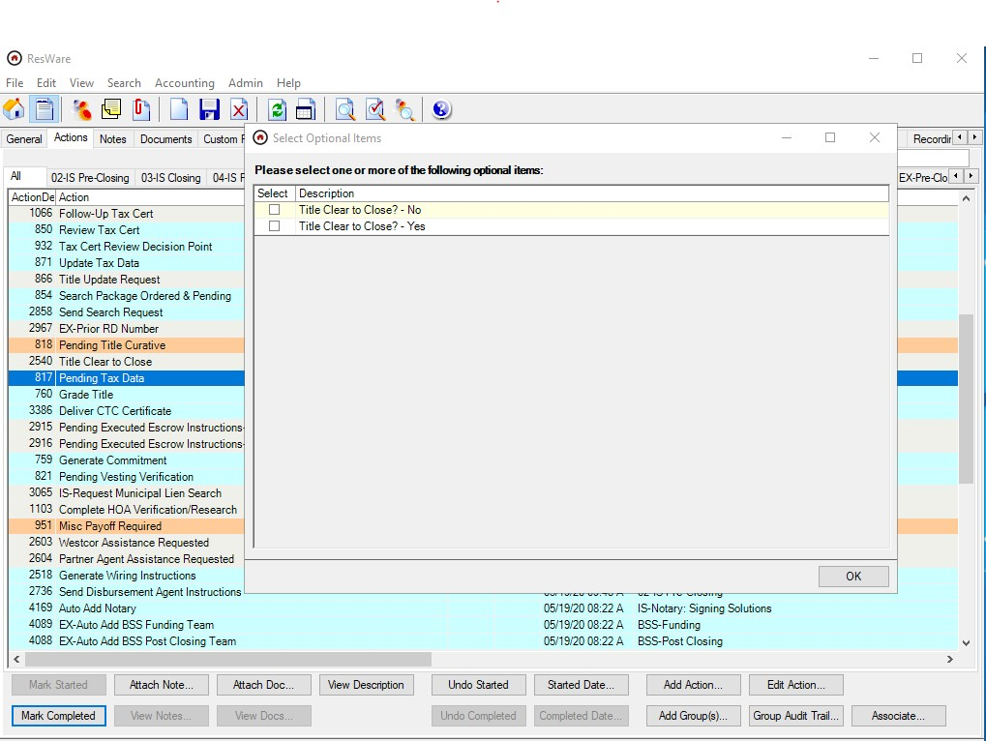

The Pending Title Curative options will re-populate. ***If title is clear to close – select Option 1: No

Curative Issues: Title Clear to Close.

If title is NOT clear to close, please select the SAME options that were selected previously selected (when grading title) For example If the Misc payoff is pending, recheck that option. grading title) For example If the Misc payoff is pending, recheck that option

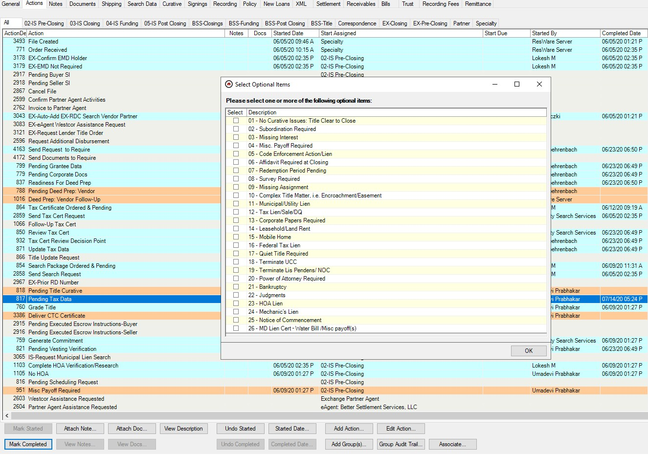

### **STEP 6: DELIVERY**

Upon completion of the actions, the revised commitment and tax statement will need to be delivered to the Client.

Go to Documents Tab and locate the Commitment and Tax Statement and select, Click Send

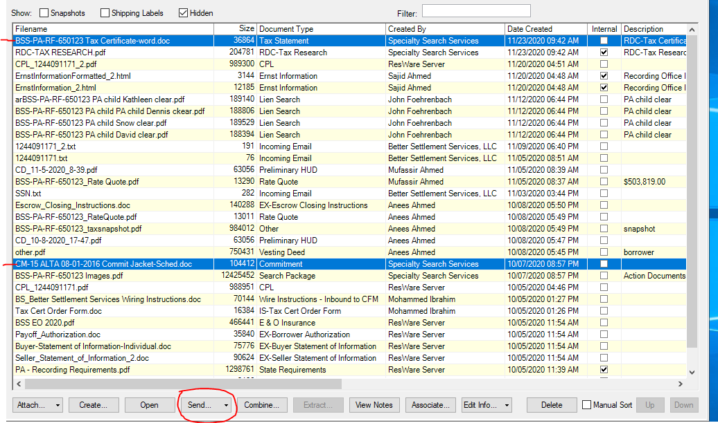

* Subject will be Revised Title Report and Tax Statement
* Body: Please find the revised title report and tax statement attached for the above referenced loan.
* Reply to: Select Drop Down and Locate Team: EMAIL – Title
* Select partners: See how to send per Client
* Click Send

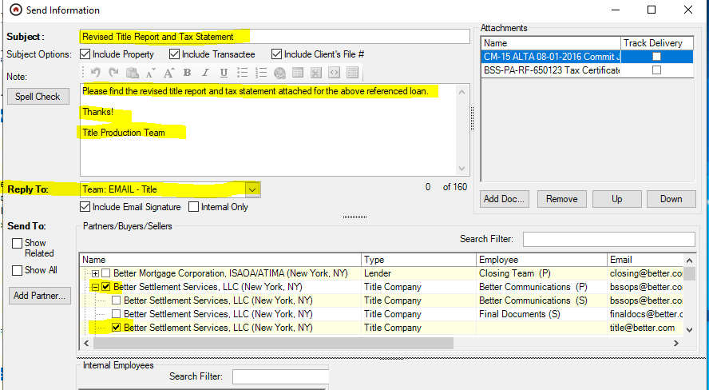

PLEASE NOTE:

* We will only deliver the tax statement if the title documents have been approved and delivered to the Client.

List of Clients and Partners:

Better Mortgage/Better Settlements:

* Partner 1:Better Settlements: bssops@better
* Partner 2: Better Settlements: [title@better.com](mailto:title@better.com)

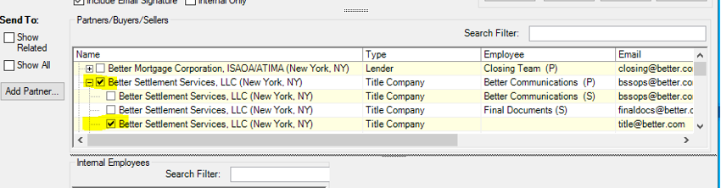

Lakeview Loan Servicing:

* Client: Lakeview Loan Servicing: [support@westvm.com](mailto:support@westvm.com)
* ****Additional partners may be auto-selected. Leave those parties as selected.

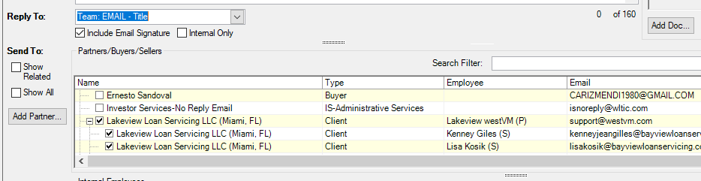

OWN UP Settlements

This is an e-agent with many lenders. When tax statement is processed, the tax statement and revised commitment must go to the contacts listed for the lender (primary and secondary, if applicable) AND the title company:

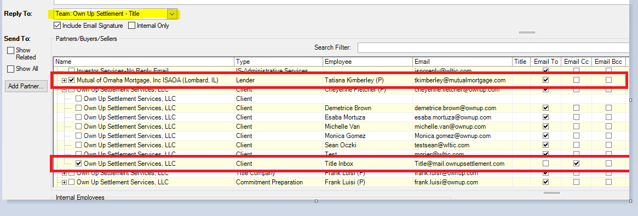

# **Index/Reference**